JOB INTERVIEWS_LISTENING EXERCISE
Listen to the job interview to practise and improve your listening skills.
Before listening
Do the preparation task first. Then listen to the audio and do the exercises.
Preparation task
Match the abbreviations (1–4) with the definitions (a–d).
Abbreviation  1. …… B2B  2. …… B2C  3. …… L&D  4. …… HR | Definition  a. learning and development  b. human resources  c. business to business  d. business to customer

Task 1
Circle the best answer.

1. Four years ago, Maria worked for a small HR services provider ...
a. in the B2B sector.
b. in the B2C sector.
c. in both B2B and B2C sectors.
2. Maria has been in her current job ...
a. for four years.
b. for three years.
c. for one year.
3. Maria’s current role is focused ...
a. only on learning and development.
b. on a number of HR topics.
c. only on payroll and she wants to do L&D.

4. Maria ...
a. did a diploma in L&D two years ago.
b. is doing a diploma in psychology at the moment.
c. Both options are true.
5. Maria will need to ...
a. identify and devise an L&D strategy.
b. devise and implement an L&D strategy.
c. implement an L&D strategy that has already been devised.
6. Maria ...
a. will hear back from them next week.
b. has been invited to a second interview next week.
c. needs to call them next week to find out the next steps.

Task 2
Complete the sentences with words from the box.
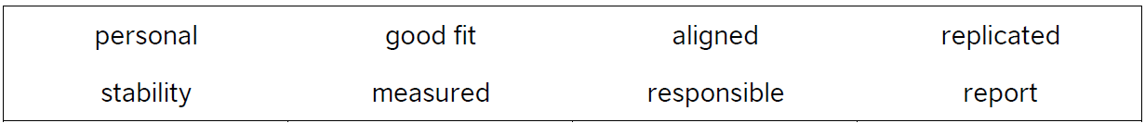

1. Maria feels her skills and experience are a ……………………………… for the company.
2. Maria changed jobs because she was looking for more ……………………………… .
3. She was ……………………………… for learning and development.
4. She feels ……………………………… with the company’s brand and values.
5. She’s used to taking a ……………………………… approach to L&D.
6. Her ideas can be ……………………………… on a larger scale.
7. She would ……………………………… to the HR manager.
8. Performance will be ……………………………… in different ways.

